
A 10
SET NO : 1

Sreenidhi Institute of Science & Technology
(An Autonomous Institution)
Code No: 101ME02

B. TECH. I – Year II – Semester Examinations, July/Aug, 2011 (Regular - FN)
ENGINEERING DRAWING - II ( IT )

Time: 3 Hours Max. Marks : 70

Note : No additional answer sheets will be provided.

Part-A (Objective Type)
Max.Marks:20

Answer all QUESTIONS.

1. List out the roles of visibility.

2. Differentiate between cutting plane method and line method of obtaining the lines of interaction.

3. Define the term " Line of intersection".

4. Draw the isometric projection of a circular plane of radius 30 mm given a point "o" as centre.

5. Draw the isometric view of hexagonal plane of side 20.

6. What is perspective view.

7. Define terms
i) Ground line ii) Vanishing point.

8. Differentiate I angle and III angle projection.

9. When do you choose the command plane.

10. Distinguish between base line and continue commands.

Part – B
Max. Marks: 50

ANSWER ANY FIVE QUESTIONS.
EACH QUESTION CARRIES 10 MARKS.

1. A vertical cylinder of 60 diameter, is penetrated by another cylinder of 45 diameter. The axes of the two cylinders are intersecting at right angle. Draw the projections of the two cylinder, showing the line (curves) of intersection.

2. A vertical cone with diameter of base 90 and axis 100 long, is penetrated by a horizontal cylinder of 50 diameter. The axis of the cylinder intersects the axis of the cone at a point 30 from the base. Draw the projections of the solids, showing the lines of intersection.

-- : 2 : --

3. Draw the isometric view of a hexagonal prism, with side of base 40 and length of axis 60. when its axis is (i) vertical and (ii) horizontal.

4. A hemi-sphere of 80 diameter, is placed centrally over a cylinder of 50 diameter and 60 long such that, the hemi - sphere rests on a point on the cylinder. The cylinder is placed centrally over a square block, with side of base 60 and 20 thick. Draw the isometric projection of the combination of solids.

5. From the given orthographic view shown in figure - I, draw the isometric view.
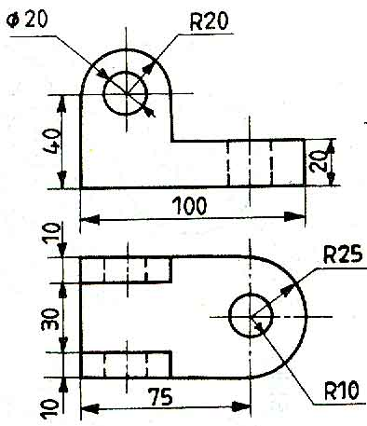

6. The isometric view of the object is shown in figure -2, draw its F.V. and S.V.
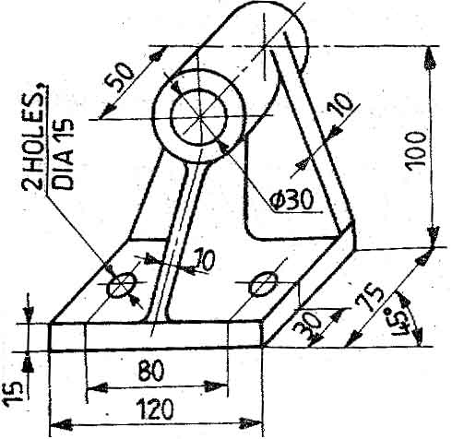

7. 4 pentagonal prism (base edge 35, axis 55), rests on one of its rectangular faces on the ground, with its axis perpendicular to P.P. The nearest pentagonal face is 10 behind P.P. The station point is 50 in front of P.P. and 25 to the left of the axis. The horizon plane contains the top - most edge of the solid. Draw the perspective projection of the solid

8. a) Give the procedure for drawing a polygon of sides and side 30 mm using AUTOCAD Commands.

b) List the various options available for the command Dimension (DIM).

-- 00 -- 00 --

